Determining the age of worker honey bees (Apis mellifera L.) that ingest pollen substitute patties

Emily R. Noordyke, Kaylin Kleckner, Cody Prouty, Jamie D. Ellis

Hypotheses
We investigated at what age worker honey bees (Apis mellifera) ingest pollen substitute patties (PSPs) by exposing cohorts of workers to dyed PSPs and evaluating the presence of the dye in their abdomen. We hypothesized that nurse bees (workers aged 5-10 days) would be the main consumers of the PSPs and have the most dye present in their abdomen given the high demand for pollen by the maturing larvae they care for (Crailsheim 1990). Alternatively, we hypothesized that PSPs would not be treated the same as bee-collected pollen stored in cells as bee bread. Therefore, foraging workers (aged 18-28 days) would be the main consumers of the PSP for their high sugar content and have the highest proportional presence of dye in their abdomen.

Methodology
Experimental design
To investigate at what age worker honey bees consume PSPs, we looked for the presence of dyed PSPs in the abdomens of worker bees each day of their lifespan. Pollen traps were placed on the entrances of fifteen colonies in five-frame Langstroth equipment to exclude local pollen foraging. The treatment groups were as follows: (1) six colonies received a dyed commercial pollen substitute, (2) three colonies received commercial pollen substitute without dye (negative control), (3) three colonies received fondant mixed with dye (positive control), and (4) three colonies received Crayola model magic clay mixed with dye (consumption control). Honey bees will not eat Crayola Model Magic clay and in some cases eject it from the hive (Noordyke et al. 2021). The negative and consumption controls were 100% effective with no dye present and the positive was 97.7% effective. Diets were fed ad libitum for 28 days and colonies were spaced 20 meters apart to reduce the chance of individuals drifting from one colony to another.

We gathered newly emerged bees < 24 h old over three consecutive days in October 2020. All newly emerged bees were placed in a single container and allowed to mix thoroughly to reduce the potential effects of genetic variation between colonies. We painted the thoraces of the newly emerged bees using Testors Enamel paint (The Testor Corporation, Rockford, IL). Groups of eight hundred painted bees were introduced to five randomly selected colonies the same day that they were painted. We heavily smoked colonies, closed colony entrances, and lightly misted the introduced bees with a sucrose solution to prevent ejection. We added appropriate diets in petri dishes (11 cm diameter, 1 cm deep) on the top bars and opened colony entrances approximately two hours after introducing the painted bees. Data collection began one day after painting, when workers were approximately two days old.

Data collection
We systematically collected 20 painted bees from each colony every day for 28 days (approximately 560 total marked workers collected per hive). We collected two painted bees per side of each of five frames. Many colonies had fewer than two painted bees per side of each frame during the last week of the study. In this case, we collected more than two painted bees on the next nearest frame until we had a full sample. Some days near the end of the study, we would not find 20 painted bees in a colony and would collect as many as we could find to get a partial sample. If we could not find any painted bees in a colony for two days in a row, then we took the colony out of the study. Bee samples were stored in the freezer at -6°C until dye extraction. We extracted dye from worker bee abdomens using methods from Noordyke et al. (2021). Two observers visually inspected samples for the presence of dye by holding vials over a white surface under the same lighting conditions. Only samples in which the two visual graders agreed were included in our statistical analysis.

We utilized weather data from the University of Florida IFAS Florida Automated Weather Network (FAWN) to account for potential environmental covariates impacting PSP consumption. We accessed hourly measurements of numerous metrics taken at the Alachua 260 station for October of 2020. We summarized the average, minimum, and maximum value of each metric per day. Additionally, we visualized the correlation between environmental metrics using a correlation matrix and corrplot::corrplot in R (version 1.4.3) to avoid selecting highly correlated metrics in our models.

Data analysis
To test our hypothesis that nurse bees (5-10 days old) would drive PSP consumption, we constructed generalized linear mixed effects models in R (version 1.4.3). We selected models with a binomial distribution and dye presence as the response variable. Our full model included worker age as linear and quadratic fixed effect predictor variables. We included the quadratic term based on our prediction that dye presence would peak at days five to ten. Additionally, we selected three biologically relevant environmental metrics to include as fixed effect covariates in our full model: average daily temperature measured 60 cm above the ground, average daily rainfall, and the maximum daily windspeed. For comparisons, we scaled all environmental covariates to have a mean of zero and a one-unit increase represent an increase of one standard deviation. To account for time-dependent hive effects, we adopted a hive random effect with a first-order autoregressive (AR1) correlation structure. An AR1 correlation structure accounts for higher correlation in time points closer together (Shan et al. 2020). From the full model, we created subsequent models with all possible combinations of environmental covariates and a variety of null models with (1) a hive random effect without AR1 correlation structure, (2) only weather variables, (3) no quadratic age fixed effect predictor variable, and (4) no predictor variables (response ~ 1). All twelve models were constructed with glmmTMB::glmmTMB (Brooks et al. 2017).

We utilized a corrected Akaike’s Information Criterion (AICc) (Akaike 1998; Symonds and Moussalli 2011) to evaluate our twelve candidate models. We calculated AICc scores, change in AICc scores ($∆$_{i}=AICc_{i} − minimum AICc), and AICc weight with MuMIn::model.sel (Bartoń 2022). We considered models with smaller AICc values and fewer predictor variables to be more parsimonious (Burnham and Anderson 2004). We considered all models with $∆$_{i} < 6 informative (Richards 2005) and averaged these models using MuMIn::model_avg (Bartoń 2022). We selected a full-model average given high model selection uncertainty (Lukacs et al. 2009). We examined estimate sizes from the averaged model to identify the important variables for our system and select the most parsimonious model for the rest of the analysis. With the most parsimonious model, Estimated Marginal Means (EMMs) and 95% confidence intervals of the proportion of dye presence were calculated across worker age using emmeans::emmeans (Lenth 2022). We visually assessed various model assumptions using simulated residuals in DHARMa:: simulateResiduals (Hartig 2022).

Results
Of our twelve constructed models, eight were within $∆$_{i} < 6 (AICc = 3345.1 - 3348.6, Table 1). All eight models included the hive random effect with AR1 correlation structure (Table 1). The averaged model revealed worker age as both a linear (estimate ± SE = 0.370 ± 0.057) and quadratic term (-0.010 ± 0.002) were important in our system. However, the estimates for all three standardized environmental variables were very miniscule (average daily temperature = 0.040 ± 0.055, average daily rainfall = -0.061 ± 0.063, maximum wind speed = 0.003 ± 0.034). Given the lack of a clear best model and very small estimates for the environmental variables in the averaged model, we selected model 3 (Table 1) to be the most parsimonious.

In our most parsimonious model, as worker age increased, the proportion of dye presence from PSP consumption gradually increased until peaking at day 20 (EMM= 0.634, 95% CI = 0.544-0.715; Figure 1, Table 2). After day 20, the proportion of dye presence gradually decreased until the end of sampling at 29 days old (Figure 1, Table 2). When examining the proportion of dye presence across worker age for each of the six hives, we found variation in the amount of dyed PSP consumed and the shape of the trend over time (VC=0.342; Figure 1). In our final model, temporal autocorrelation was strong (AR1 correlation coefficient = 0.86). All model assumptions were satisfied through visual inspection of the simulated residuals.

Interpretation
Our study investigated at what age do adult worker honey bees consume PSPs. While artificial pollen supplements are widely used by beekeepers, little is known regarding their consumption or effectiveness. To understand how effective PSPs are, we first must investigate whether they are consumed at all. We hypothesized that workers aged 5-10 days acting as nurse bees would consume the most PSPs due to the demand of pollen from growing honey bee larvae. Alternatively, we hypothesized workers aged 18-28 days serving as foragers would consume the most PSPs for energy.

From our experiment, our alternative hypothesis was more strongly supported. PSP consumption gradually increased throughout days 5-10 but peaked at day 20 – well after workers are serving as nurse bees. The pattern of PSP consumption varied from hive-to-hive, with one hive demonstrating a linear trend of PSP consumption increasing steadily throughout worker age. Environmental variables did not appear to affect PSP consumption patterns in our system. Across seasons or a longer experimental period patterns of environmental covariates and PSP consumption may emerge. Hive variation and the lack of environmental covariate influence suggests PSP consumption is dependent on internal colony needs, such as existing resources, cohorts of workers, and amount of developing brood. We suggest the absence of peak PSP consumption at the age of nursing workers means PSPs are not treated like bee-collected pollen. Therefore, using PSPs to supplement colony protein requirements may be futile. Future research is needed to investigate other forms of pollen supplementation to assist beekeepers in treating colony nutrient deficiencies.

Figures and tables
Table 1. Evaluation of twelve candidate models with variable fixed effect predictor variables and random effect structure via corrected Akaike’s Information Criterion (AICc).
 | Candidate Models | Random effect | df | AICc | $∆$_{i} | AICc weight
1 | A+A² +R+W | A | H | 7 | 3345.1 | 0.00 | 0.256
2 | A+A² +R | A | H | 6 | 3345.5 | 0.44 | 0.206
3 | A+A² | A | H | 5 | 3346.2 | 1.14 | 0.145
4 | A+A² +W | A | H | 6 | 3346.7 | 1.58 | 0.117
5 | A+A² +T+R+W | A | H | 8 | 3347.1 | 1.97 | 0.096
6 | A+A² +T+R | A | H | 7 | 3347.3 | 2.24 | 0.083
7 | A+A² +T | A | H | 6 | 3348.2 | 3.15 | 0.053
8 | A+A² +T+W | A | H | 7 | 3348.6 | 3.52 | 0.044
9 | A | A | H | 4 | 3372.2 | 27.07 | 0.000
10 | T+R+W | A | H | 6 | 3383.9 | 38.76 | 0.000
11 | A | 1 | H | 3 | 3431.1 | 85.98 | 0.000
12 | 1 | NA | 1 | 3730.4 | 385.31 | 0.000

Predictor variables: A=Linear age term, A²=Quadratic age term, T=Average daily temperature, R=Average daily rainfall, W=Maximum daily windspeed, 1=Null model
Random effect structure: A | H = Hive random effect with first-order autoregressive (AR1) correlation structure, 1 | H = Hive random effect, NA = not applicable
$∆$_{i} : AICc_{i} − minimum AICc

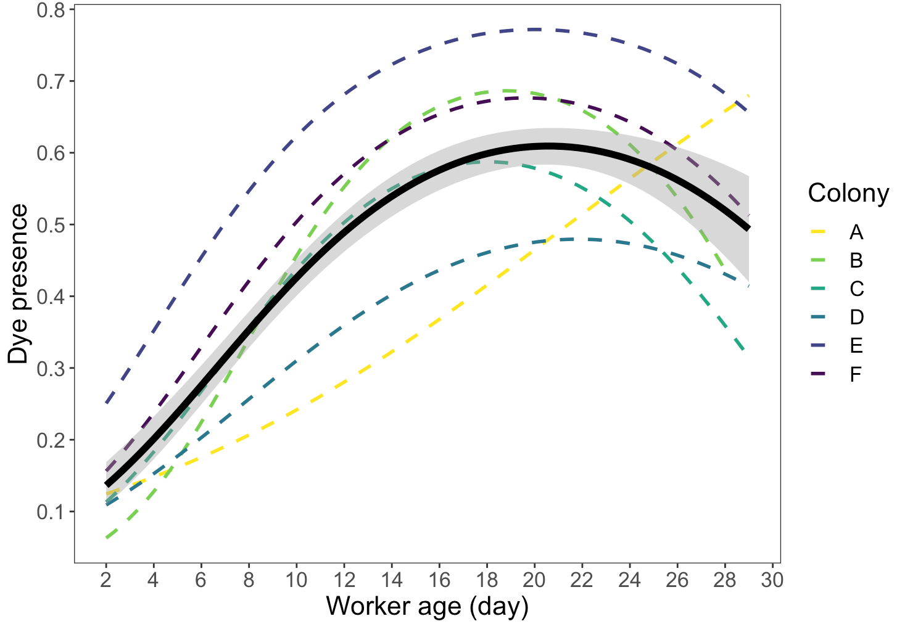
Figure 1. Proportion of dye presence from pollen substitute patty consumption as worker age increases. The continuous black line represents the estimated curve from a generalized linear model with a binomial distribution of all colonies. Estimated curves for each of the six colonies are represented by the multicolor dashed lines. Dye presence peaks at approximately day 20, but varies by colony.

Table 2. Estimated Marginal Means (EMMs) and 95% confidence intervals back-transformed to the proportion of dye presence in the abdomens of adult worker honey bees at various ages.
Age of workers (day) | Proportion of workers with dye (EMM) | 95% CI
2 | 0.0919 | 0.053-0.156
4 | 0.159 | 0.105-0.233
6 | 0.246 | 0.180-0.328
8 | 0.344 | 0.266-0.431
10 | 0.437 | 0.349-0.529
12 | 0.515 | 0.420-0.609
14 | 0.574 | 0.477-0.666
16 | 0.613 | 0.517-0.701
18 | 0.633 | 0.540-0.717
20 | 0.634 | 0.544-0.715
22 | 0.617 | 0.526-0.700
24 | 0.581 | 0.482-0.674
26 | 0.525 | 0.409-0.639
28 | 0.450 | 0.312-0.596

References
Akaike, H. 1998. Information Theory and an Extension of the Maximum Likelihood Principle, pp. 199–213. In Parzen, E., Tanabe, K., Kitagawa, G. (eds.), Selected Papers of Hirotugu Akaike, Springer Series in Statistics. Springer New York, New York, NY.
Bartoń, K. 2022. MuMIn: Multi-Model Inference. R package version 1.46.0. https://CRAN.R-project.org/package=MuMIn
Brooks, M. E., K. Kristensen, K. J. van Benthem, A. Magnusson, C. W. Berg, A. N., H. J. Skaug, M. Maechler and B. M. Bolker. 2017. glmmTMB Balances Speed and Flexibility Among Packages for Zero-inflated Generalized Linear Mixed Modeling. The R Journal, 9(2), 378-400.
Burnham, K. P., and D. R. Anderson. 2004. Multimodel Inference: Understanding AIC and BIC in Model Selection. Sociological Methods & Research. 33: 261–304.
Crailsheim, K. 1990. The protein balance of the honey bee worker. Apidologie. 21: 417–429.
Hartig, F. 2022. DHARMa: Residual Diagnostics for Hierarchical (Multi-Level/Mixed) Regression Models. R package version 0.4.5. https://CRAN.R-project.org/package=DHARMa
Lenth, R. V. 2022. emmeans: Estimated Marginal Means, aka Least-Squares Means. R package version 1.7.2. https://CRAN.R-project.org/package=emmeans
Lukacs, P. M., K. P. Burnham, and D. R. Anderson. 2009. Model selection bias and Freedman’s paradox. Ann Inst Stat Math. 62: 117.
Noordyke, E. R., E. v. Santen, J. D. Ellis. 2021. Tracing the Fate of Pollen Substitute Patties in Western Honey Bee (Hymenoptera: Apidae) Colonies. Journal of Economic Entomology. 114:4. 1421–1430,
Richards, S. A. 2005. Testing ecological theory using the information-theoretic approach: examples and cautionary results. 86: 10.
Shan, G., H. Zhang, and T. Jiang. 2020. Correlation Coefficients for a Study with Repeated Measures. Comput Math Methods Med. 2020: 7398324.
Symonds, M. R. E., and A. Moussalli. 2011. A brief guide to model selection, multimodel inference and model averaging in behavioural ecology using Akaike’s information criterion. Behav Ecol Sociobiol. 65: 13–21.

